ISSACK WAITHAKA
cs-sa07-24085

Splunk: Exploring SPL
- Splunk is a powerful SIEM solution that provides the ability to search and explore machine data.
- Search Processing Language (SPL) is used to make search more effective.
- I was able to start my machine.
Questions
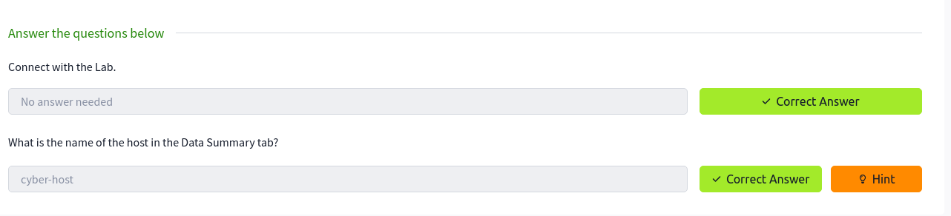
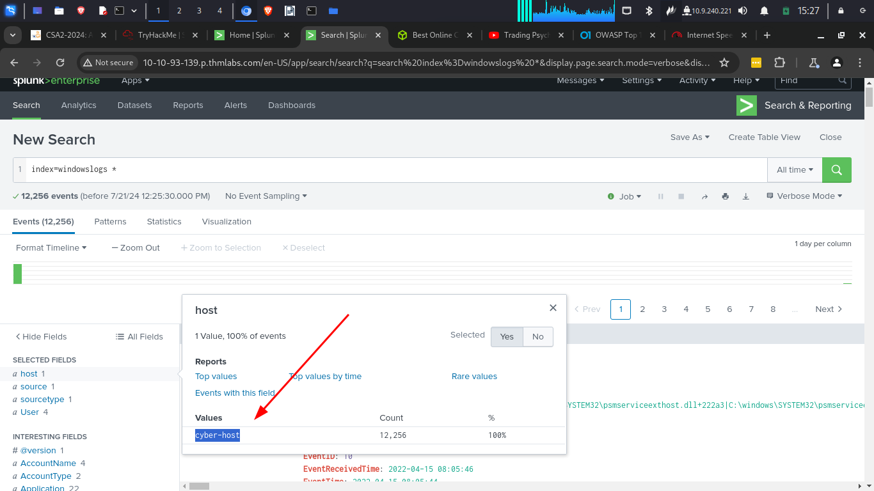

Search and reporting app overview
- Search head is where we use search processing language queries to look for the data.
Questions
1.

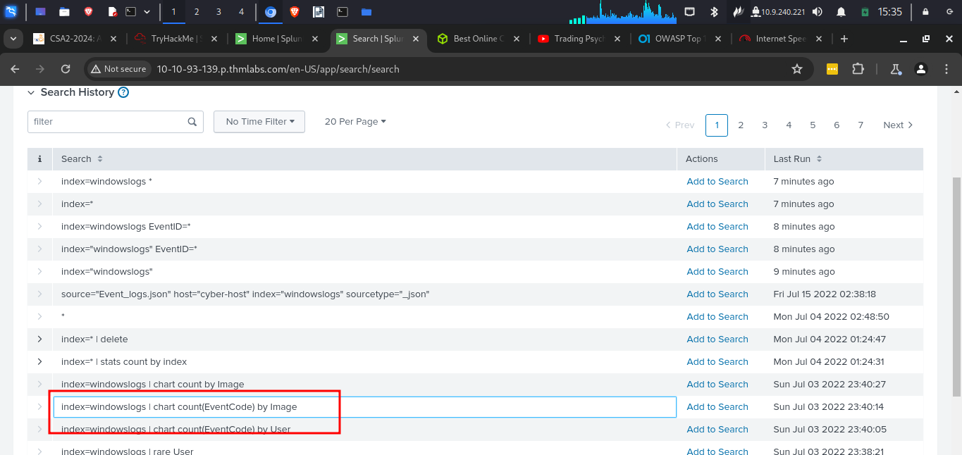
2.

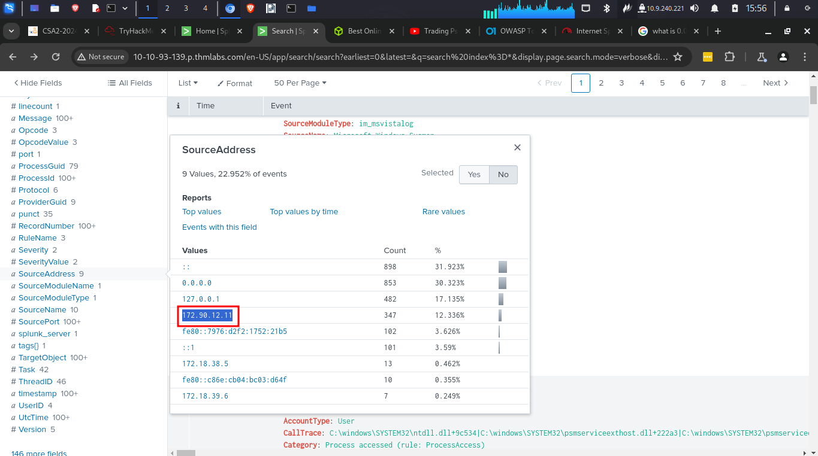
3.

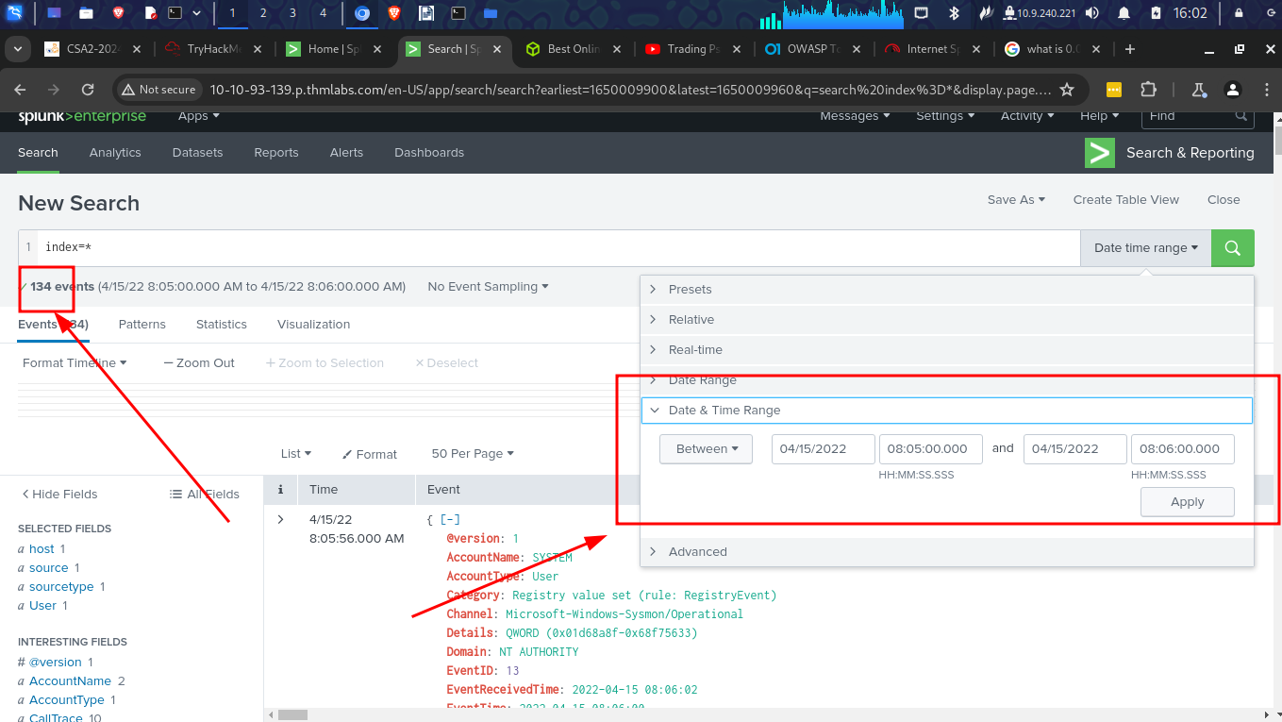
Splunk Processing Language Overview
- Splunk field operators are building blocks used to construct any search query.
- It consists of Comparison operators and also boolean operators
Questions
1.

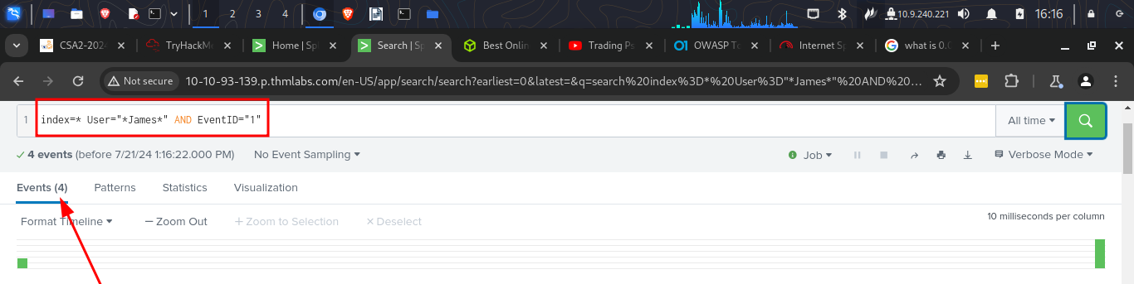
2.

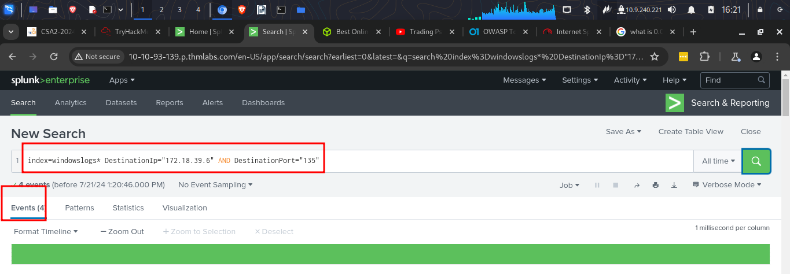
3.
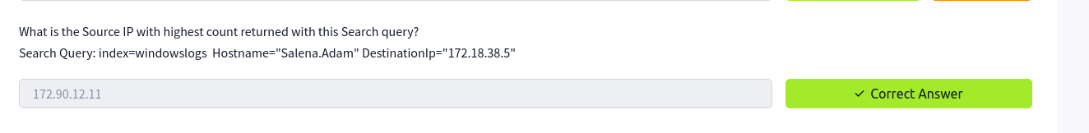
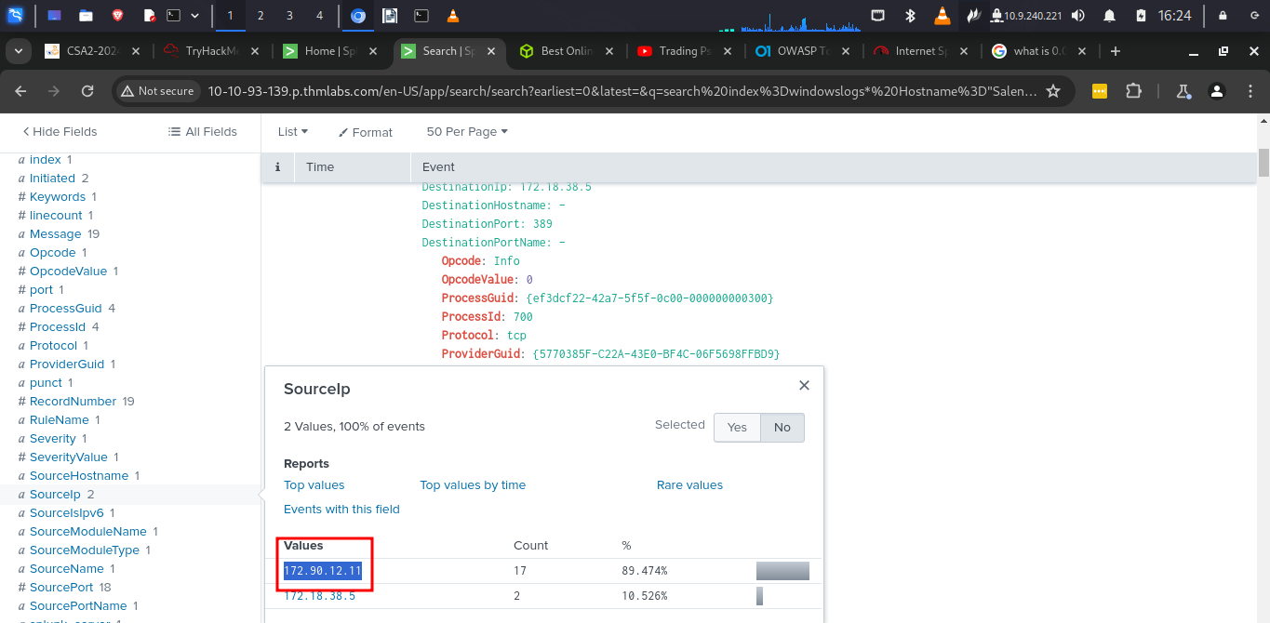
4.

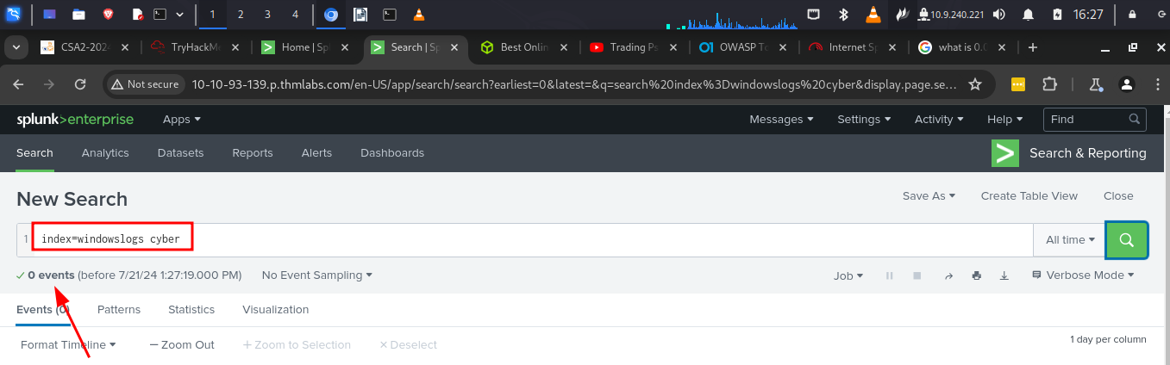
5.

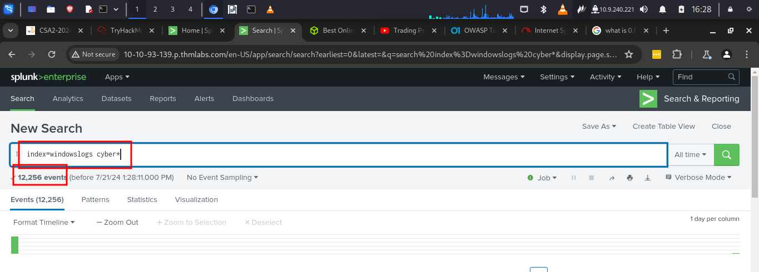

Filtering results in SPL
- We can add or remove certain data from the results
Questions
1.
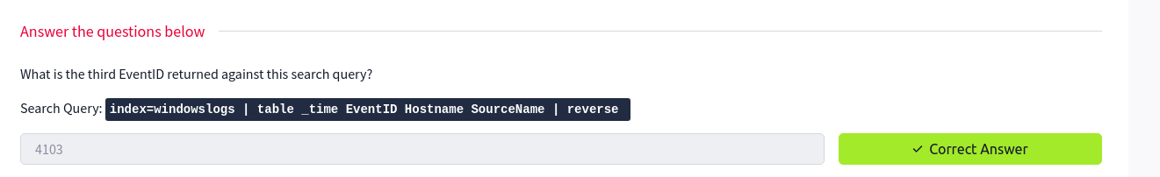
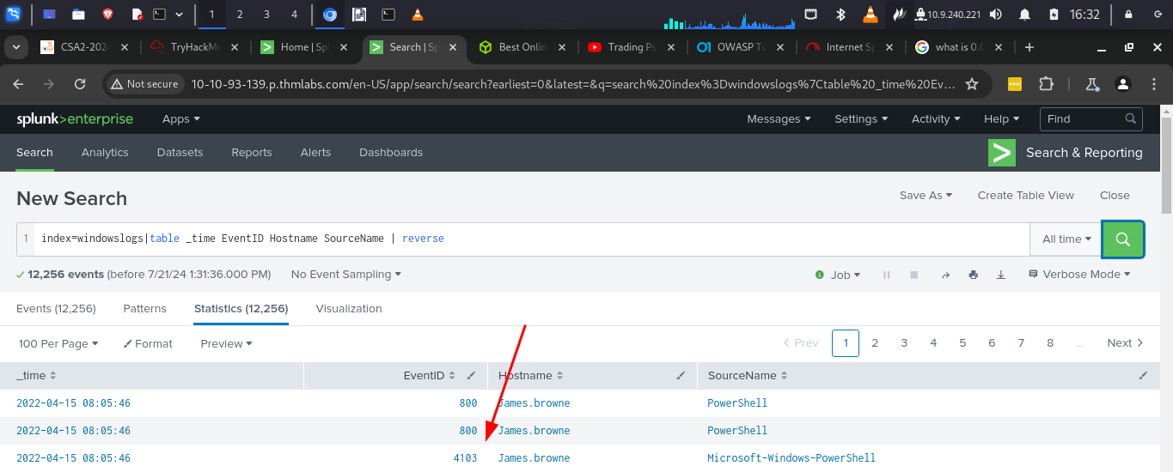
2.
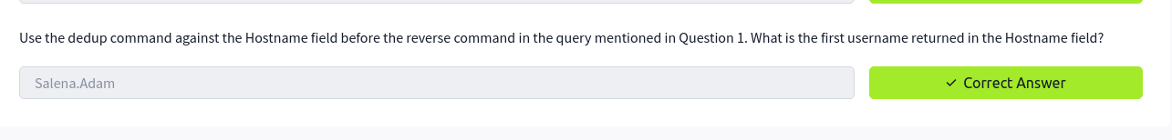
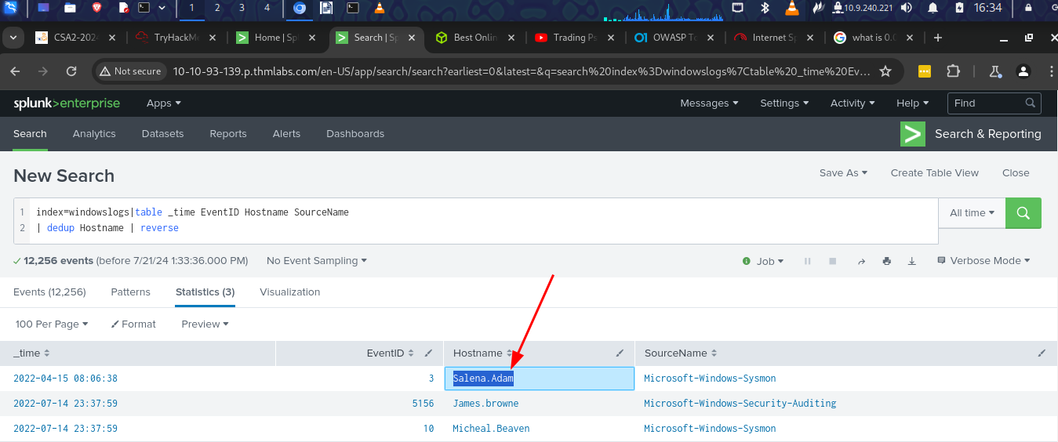

Spl - structuring the Search query
- Provides various commands to bring structure or order to the search results.
Questions
1.
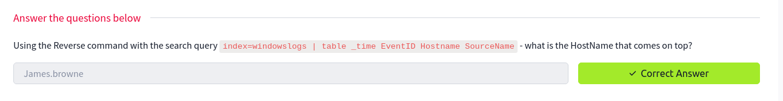
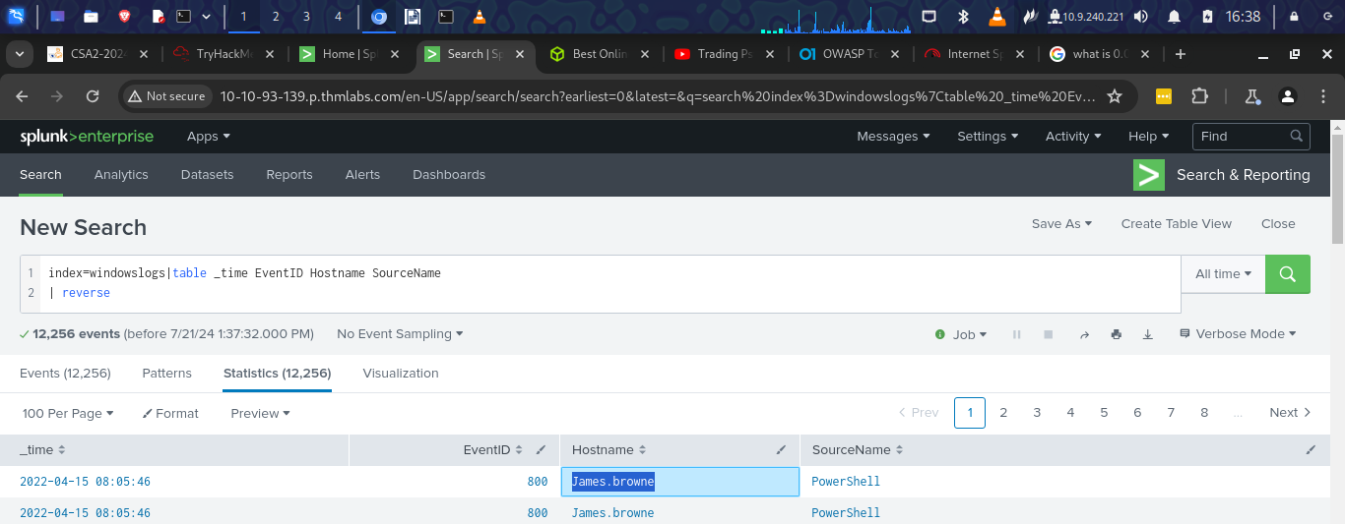
2.

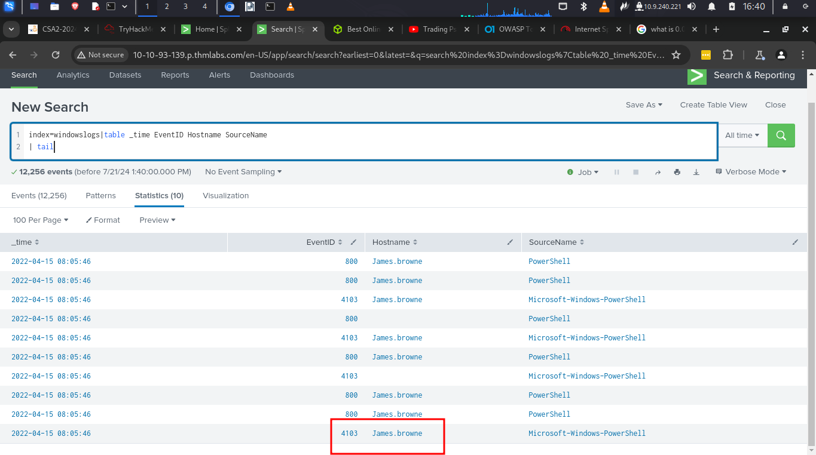
3.

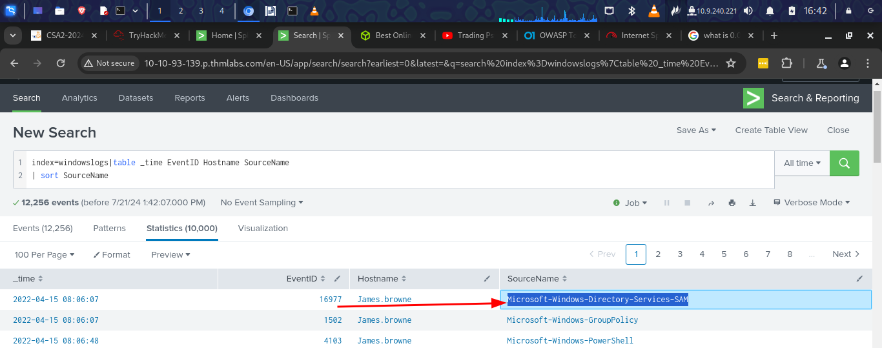
Transformation commands in SPL
- These are commands which the results into a data structure from field value pairs
Questions
1.

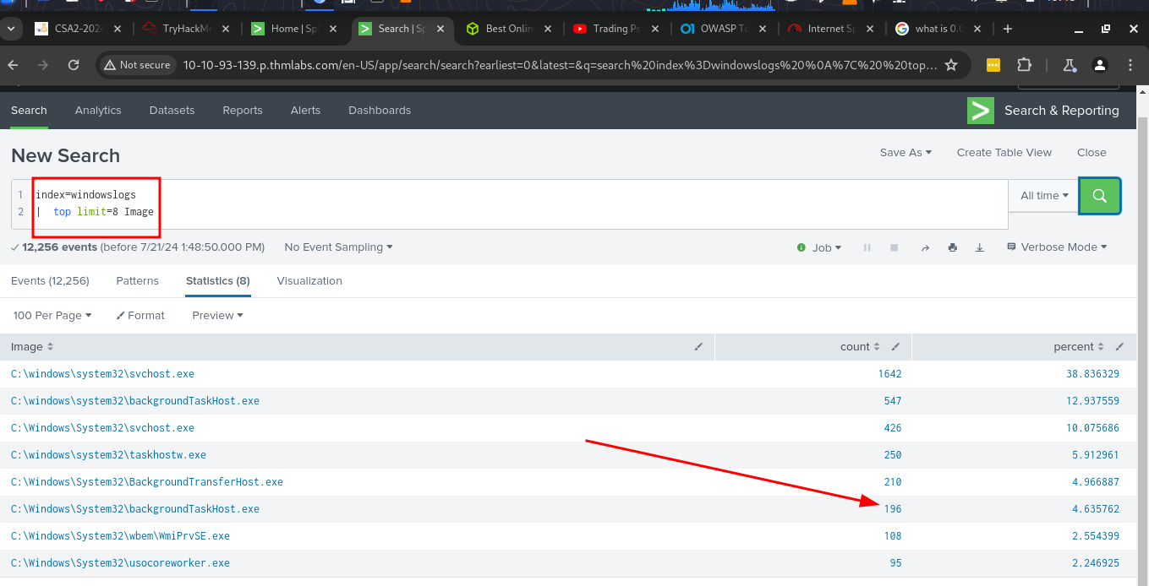
2.

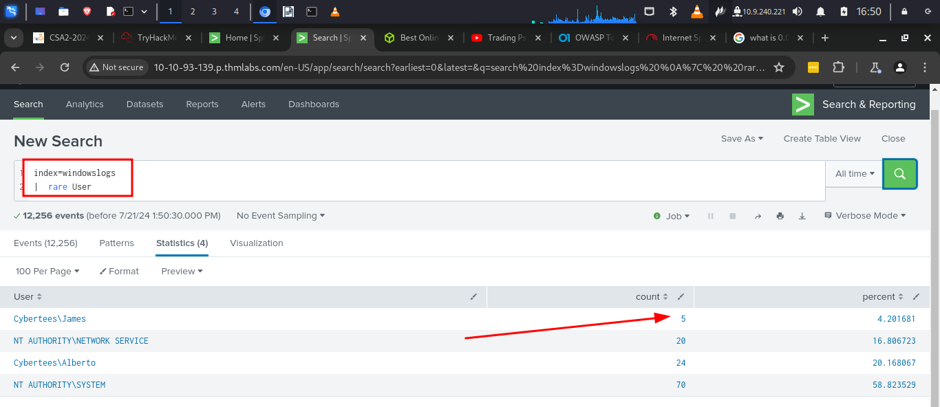
3.

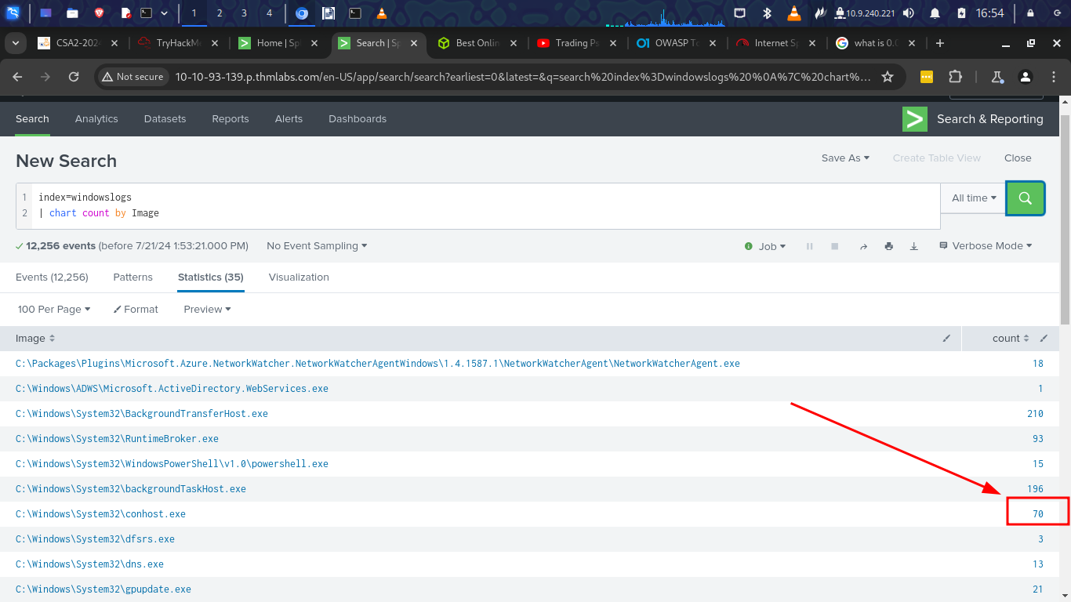

Conclusion
In this room I have learnt about Splunk which is a tool that helps to search and explore machine data. It is a very useful tool when dealing with huge amount of data. This tool can filter, sort structure results that is obtained. It is a very useful tool.

